# Exercise: Adding an aggregation

## **Introduction**

You have gained a thorough understanding of creating and managing aggregations in Microsoft Power BI while working with a DirectQuery connection. You have also learned how aggregations can help improve query performance.

In this exercise, you can apply this knowledge by creating and managing an aggregation in Power BI using import data. You will also be able to observe how significantly it reduces the size of the data table.

By completing this exercise, you will demonstrate your ability to:

* Create an aggregation based on specific granularity of analytics.
* Configure the data types of aggregated columns and source columns.
* Manage the aggregation in Power BI desktop.

## **Scenario**

One of the Adventure Works data sets used in a Power BI report is very large. The report performance has been negatively impacted by the need to query the entire data table each time a user interacts with visuals and filters. You feel that creating an aggregation will solve the issue.

To implement this solution, you must create a new aggregated table, establish relationships, and then manage the aggregations within Microsoft Power BI desktop.

Adventure Works provides a Power BI project file called AdventureWorks.pbix. that contains the required data model and an Excel spreadsheet Adventure Works Data.xlsx. You must download these files and load it into Power BI.

### **Step 1: Download the Adventure Works Power BI project.**

1. Download and save the Power BI file *Adventure Works.pbix*. The data model has three tables of data: Sales, Products, and Date.
2. Download and save the Excel spreadsheet Adventure Works Data.xlsx.
3. Next, select on File in the top-left corner of the screen. In the dropdown menu, hover over Options and settings, and then select Data source settings.
4. A new window titled Data source settings will appear. Here, you'll see a list of all the data sources currently used in your Power BI reports.
5. After selecting the data source, click on Change Source... to modify its details. Navigate to the file location of the Adventure Works Data spreadsheet.
6. Once you’ve made the necessary changes, select OK to confirm and Power BI will validate the new connection.

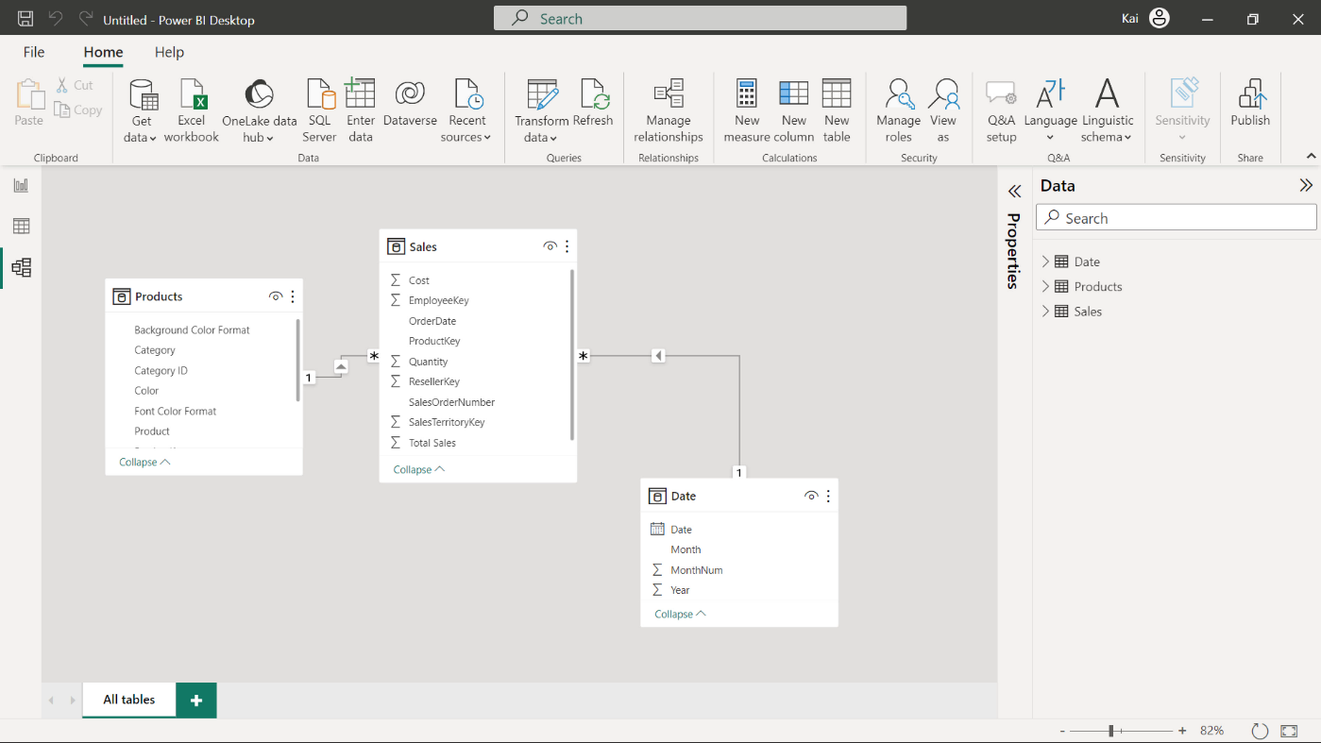

### **Step 2: Create an aggregated table.**

1. Within your data model, create an aggregation named “SalesAgg”. You need to use the Power Query editor to create an aggregation while keeping the original fact table intact.
2. Group the aggregation by Order Date field. Create TotalQuantityCount, SumTotalSales, and SumCost as aggregate columns in the new aggregations.
3. Note the number of rows in the original fact table and in the aggregated table.

Tip: You can create this aggregation in the Query editor of Power BI. You can also employ the Choose columns and group by features of the Power Query editor.

### **Step 3: Establish a relationship and manage aggregation in Power BI.**

1. Establish a relationship between the SalesAgg table and Date table based on the Order Date field.
2. Ensure the data types of aggregate columns match the source columns.

Tip: You can create relationships in the Model view of Power BI. You can navigate back to the Query editor to match the data types. And you can manage aggregations in the Microsoft Power BI Modeling tab.

### **Step 4: Save the Power BI project.**

1. Save your Power BI project.

Tip: Make sure you select an appropriate project name and folder path.

## **Conclusion**

With these steps, you have successfully created an aggregation within Power BI to significantly reduce the size of the original dataset, which was a fact table containing millions of rows. This approach helps to optimize the query performance and visual refresh time. These optimization measures will help you analyze Adventure Works data based on the required granularity levels.